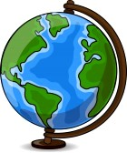
World Geography
Interactive Notebook
Table of Contents
Page  #(s) | Title | Date Added | Checked

